Report by:
Deston Guay (Team Leader)
Randy Tung
Eugene Lee
Benedict Say
Darwin Tan
Joshua Tan

CSCI212 – Team C1 Assignment 2 Report

CSCI222 Assignment 2 Report

Team Number : <C1 >

 | Student Number | Name | Email Address
1 | 6096761 | Deston Guay Jie Khai | Tel: 98376600 Email: djkg997@uowmail.edu.au
2 | 6097558 | Darwin Tan | Darwin_tan88@hotmail.com
3 | 6097364 | Benedict Say | Bensay22@gmail.com
4 | 6096888 | Eugene Lee | Eugene_2394@hotmail.com
5 | 6096839 | Joshua Tan | 1.2silverfish@gmail.com
6 | 6097340 | Randy Tung | 123613p@gmail.com

Table of Contents
Contents
Project Overview 3
Roles and Responsibility 5
Risk Analysis and Counter Measures 6
Design Artefacts - Use Cases (Iteration 1) 7
Design Artefacts - Use Cases (Iteration 2) 8
Design Artefacts - Activity Workflows (Iteration 1) 9
Design Artefacts - Activity Workflows (Iteration 2) 10
Design Artefacts - Component Diagrams (Iteration 1) 11
Design Artefacts - Component Diagrams (Iteration 2) 15
Design Artefacts - Class Diagrams (Iteration 1) 21
Design Artefacts - Class Diagrams (Iteration 2) 22
Appendix A - Formal Meeting Records 23
Appendix B - Individual Work Diaries 24
Appendix C - Evidence of using VCS (Version Control Software) 30

Project Overview

In this assignment, the primary focus is targeted at the ability to provide a warehouse inventory management system for the user. This system is crucial as it will strive to streamline processes and optimise productivity and day-to-day operations. Staff members are able to make use of the provided summary data to conduct critical decision-making operations that will directly impact the organization.

It is therefore paramount for the organization to have an effective system in place with an effective security coverage, pinpoint accuracy for data summary and a robust system to maintain the highest uptime.

- "Vision"

We strive to create a program which is closely suited to user requirement and have as little constraints as possible that will impede the user’s experience.

- Initial Use-Case Model

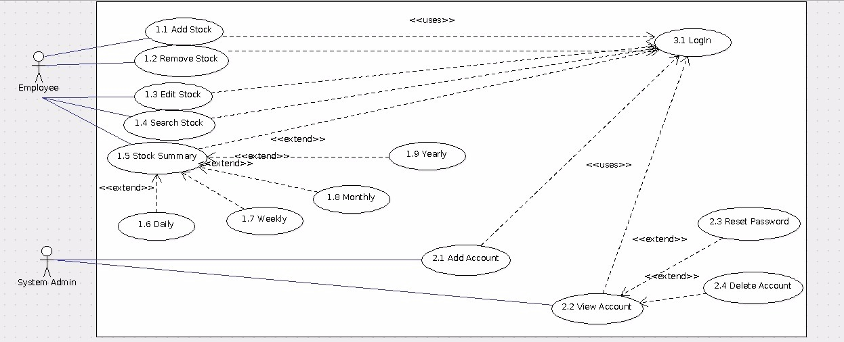

As shown in the diagram above, there are mainly two actors; Employee and System Admin who will be required to using login to use any of the use case.

For the Employee they can do the following: Add Stock, Remove Stock, Edit Stock, Search Stock and Stock Summary. Stock Summary is then extended to Daily, Weekly, Monthly and Yearly.

For the System Admin they can do the following: Add Account and View Account. Which View Account is extended to Reset Password and Delete Account.

- Project Plan

- Please refer to "Stud_GanttChart_Sample.xls" for planning your system development activities

- Overlay your RUP iterations to Gantt charts timeline (e.g. which phase-iteration relates to which week?

- Also, within each week, what are the development activities, start-end date, duration (no. of man-days), and who is in charge of each activity?)

- If you are pasting screen-shots of your project planning into this sub-section, please ensure all the wordings / text are clearly visible

(i.e. assume anything < Arial Font_Size_10 is NOT easily visible to your company's senior management!)

Roles and Responsibility

Team Number: <C1>

 | Student Name | Role | Artefacts
1 | Deston Guay |  | < E.g. Use Case Diagram, Report - Section 2, TestCase.h, TestCase.cpp, etc >
2 | Randy Tung
3 | Eugene Lee
4 | Benedict Say
5 | Darwin Tan
6 | Joshua Tan

Risk Analysis and Counter Measures

 | Impact Type | Risk Seriousness (%) | Likelihood of Occurrence (%) | WBS  (affected work / task) | Risk Description
1 | Budget | 30% | 5% | All | All employees demand an increment of salary.
2 | Competitive | 50% | 30% | Stock | Potential competitors to institute a price war to cause a drop in revenue.
3 | Compliance | 10% | 5% | All | A risk level that the company will be deemed to have violated a law or regulation.
4 | Operations | 50% | 10% | All | The potential risk for failures of the company’s core business processes.
5 | Security | 20% | 20% | All | Risks related to physical and information security.

 | Risk Description | Proposed Mgmt Plan | (Possible) Reduction in Risk Seriousness (%)
1 | All employees demand an increment of salary. | Plan 1: Propose appropriate increment of salary | -20%
1 | All employees demand an increment of salary. | Plan 2: Replace disgruntled workers | -20%
2 | Potential competitors to institute a price war to cause a drop in revenue. | Plan 1: Offer discounts and benefits for customers | -50%
3 | A risk level that the company will be deemed to have violated a law or regulation. | Plan 1: Ensure that the country’s laws and legislature are adhered to at all times. | -10%
4 | The potential risk for failures of the company’s core business processes. | Plan 1: Ensure business continuity plan is in place and rehearsed with employees. | -50%
5 | Risks related to physical and information security. | Plan 1: Review security processes frequently | -10%
5 | Risks related to physical and information security. | Plan 2: Review inactive accounts and implement a password change policy | -10%

Design Artefacts - Use Cases (Iteration 1)

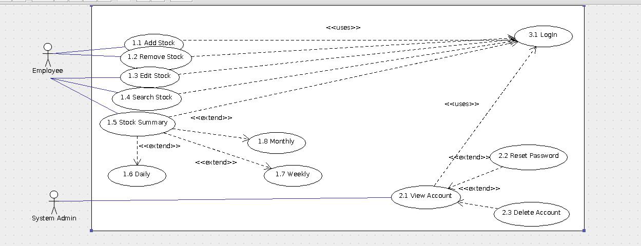

Design Artefacts - Use Cases (Iteration 2)

Design Artefacts - Activity Workflows (Iteration 1)

You may use any diagramming tool to develop your activity diagrams for the entire system.

Iteration 1 is based on your team's "INITIAL" understanding of the system.

Note 1 : Your diagram should be developed using standard UML symbols and notations for activity diagrams!

Note 2 : this section can span as many pages as necessary

Note 3 : If you are pasting screen-shots (from your adopted diagramming tool) into this sub- section, please ensure the wordings / text are clearly visible

Design Artefacts - Activity Workflows (Iteration 2)

You may use any diagramming tool to develop your activity diagrams for the entire system.

Iteration 2 is based on your team's "LATEST" understanding of the system.

In general, the diagrams in later iterations should be more refined, more evolved, capture more details than diagrams developed in earlier iterations

Note 1 : Your diagram should be developed using standard UML symbols and notations for activity diagrams!

Note 2 : this section can span as many pages as necessary

Note 3 : If you are pasting screen-shots (from your adopted diagramming tool) into this sub- section, please ensure the wordings / text are clearly visible

Design Artefacts - Component Diagrams (Iteration 1)

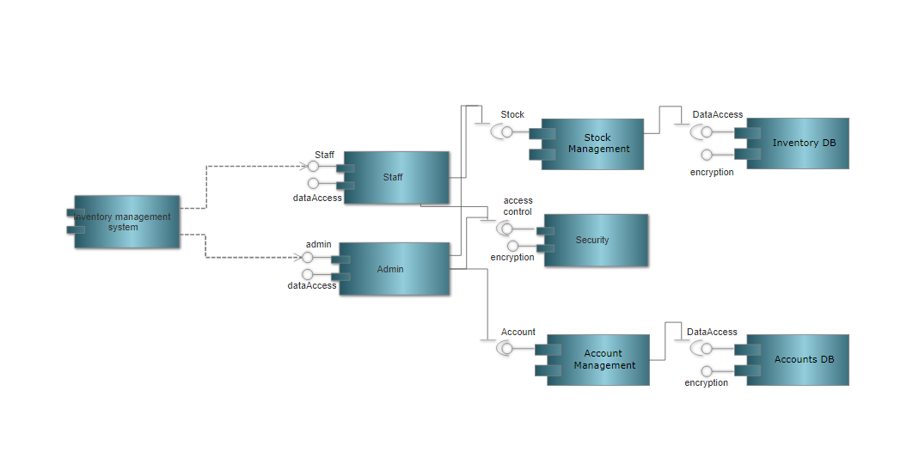

Design Artefacts - Component Diagrams (Iteration 2)

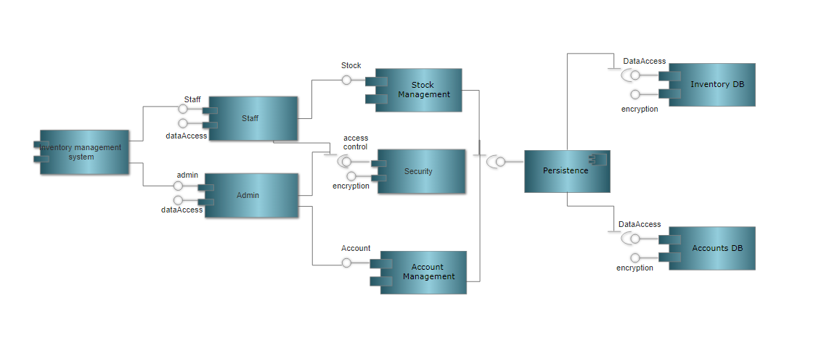

Design Artefacts - Class Diagrams (Iteration 1)

You may use any diagramming tool to develop your class diagrams for the entire system.

Iteration 1 is based on your team's "INITIAL" understanding of the system.

Note 1 : Your diagram should be developed using standard UML symbols and notations for class diagrams!

Note 2 : this section can span as many pages as necessary

Note 3 : If you are pasting screen-shots (from your adopted diagramming tool) into this sub- section, please ensure the wordings / text are clearly visible

Design Artefacts - Class Diagrams (Iteration 2)

You may use any diagramming tool to develop your class diagrams for the entire system.

Iteration 2 is based on your team's "LATEST" understanding of the system.

In general, the diagrams in later iterations should be more refined, more evolved, capture more details than diagrams developed in earlier iterations

Note 1 : Your diagram should be developed using standard UML symbols and notations for class diagrams!

Note 2 : this section can span as many pages as necessary

Note 3 : If you are pasting screen-shots (from your adopted diagramming tool) into this sub- section, please ensure the wordings / text are clearly visible

Design Artefacts - Sequence Diagrams (Iteration 1)

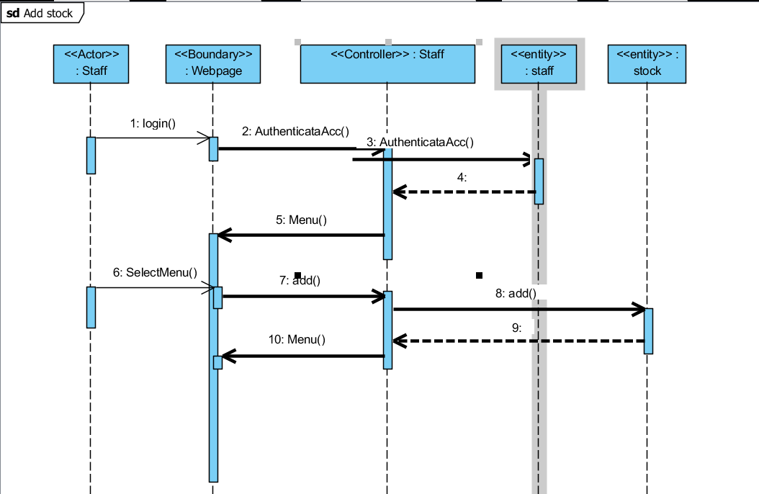

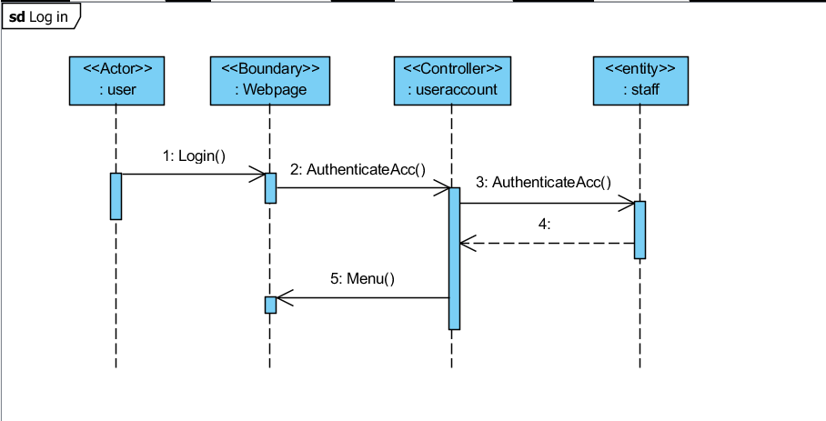

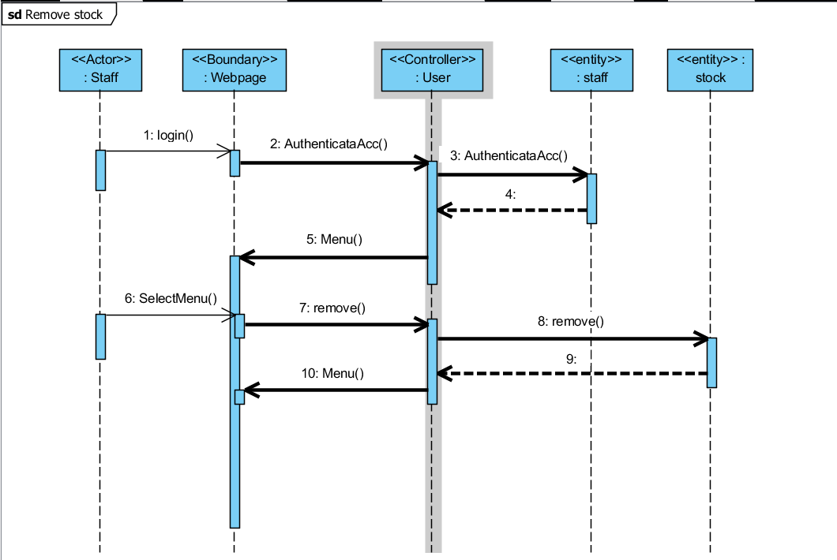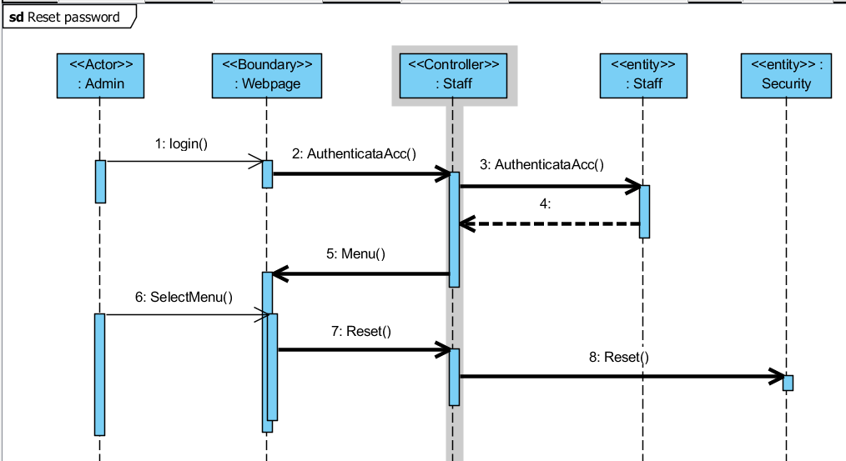

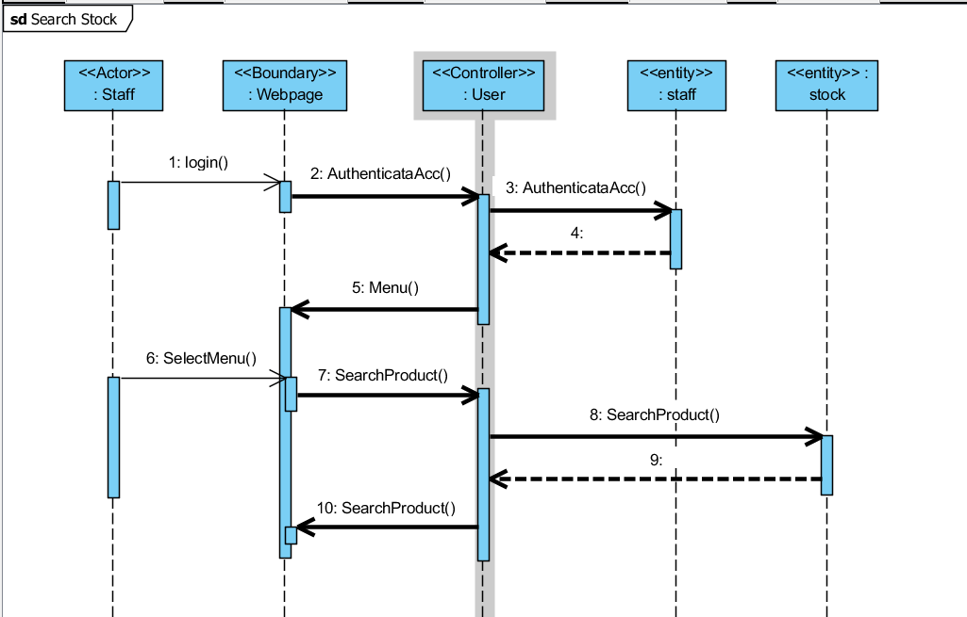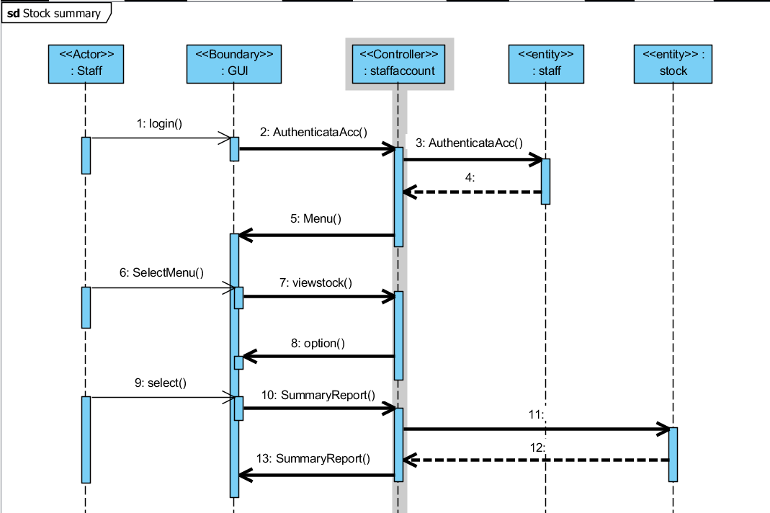

Design Artefacts - Sequence Diagrams (Iteration 2)

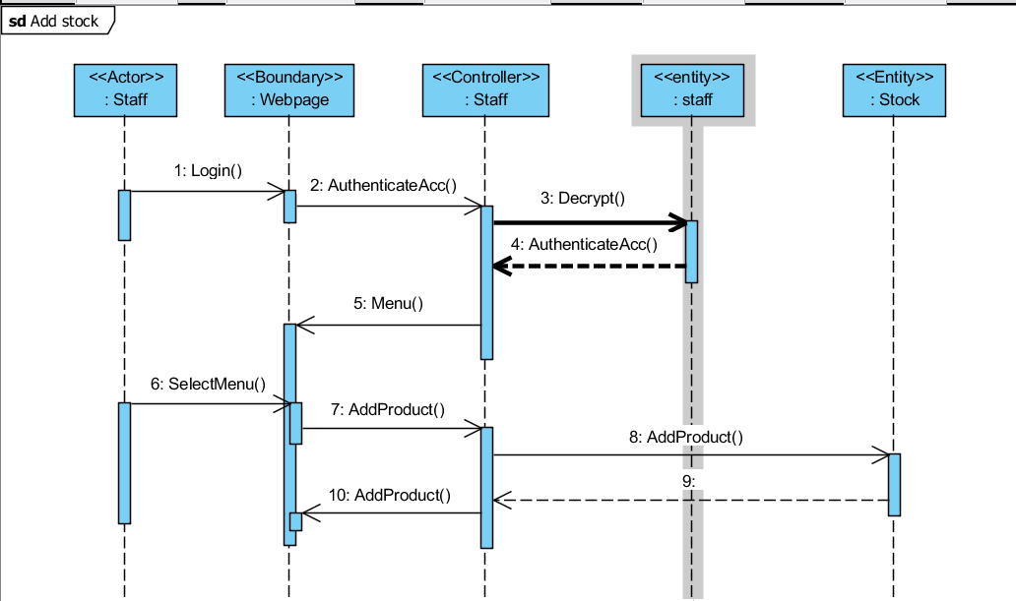
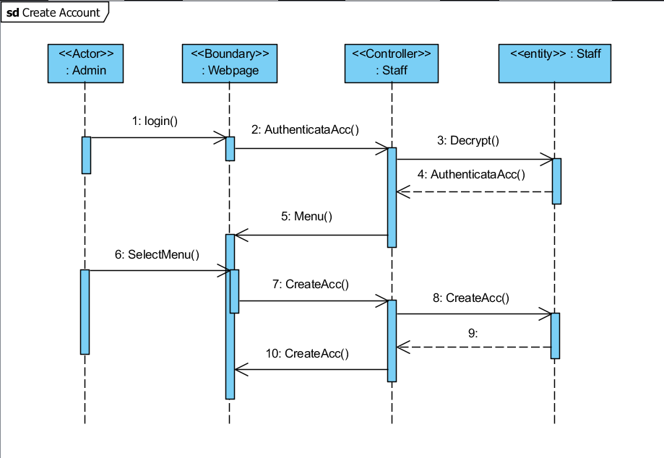

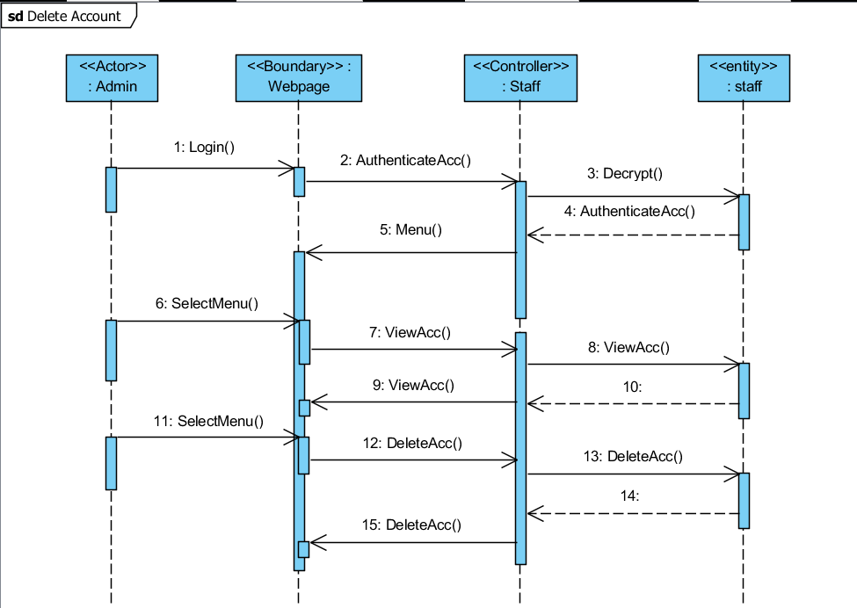
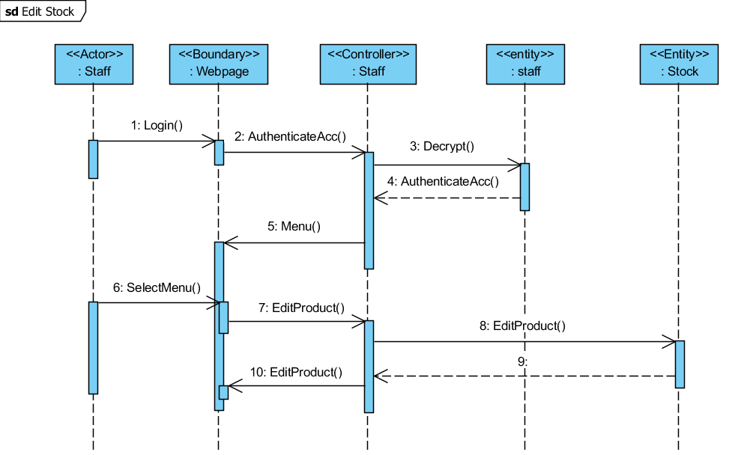

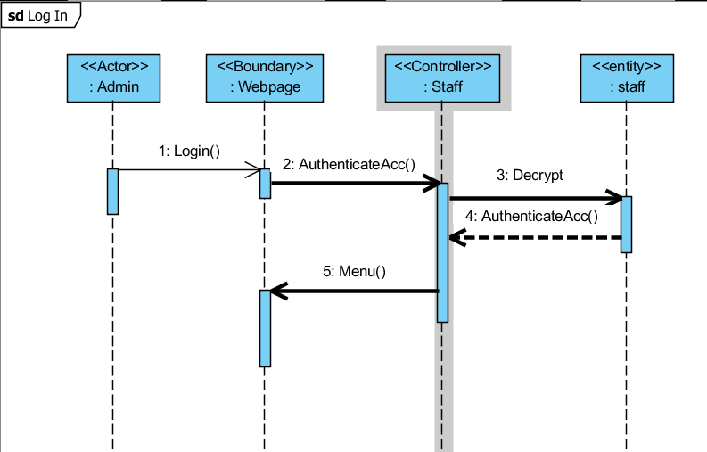
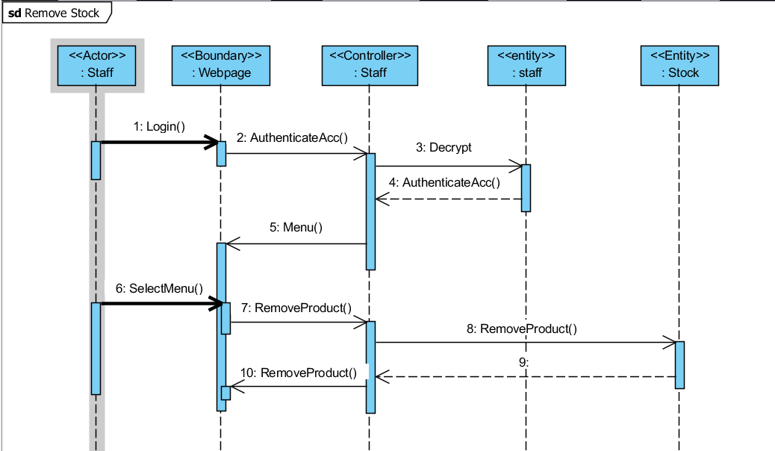

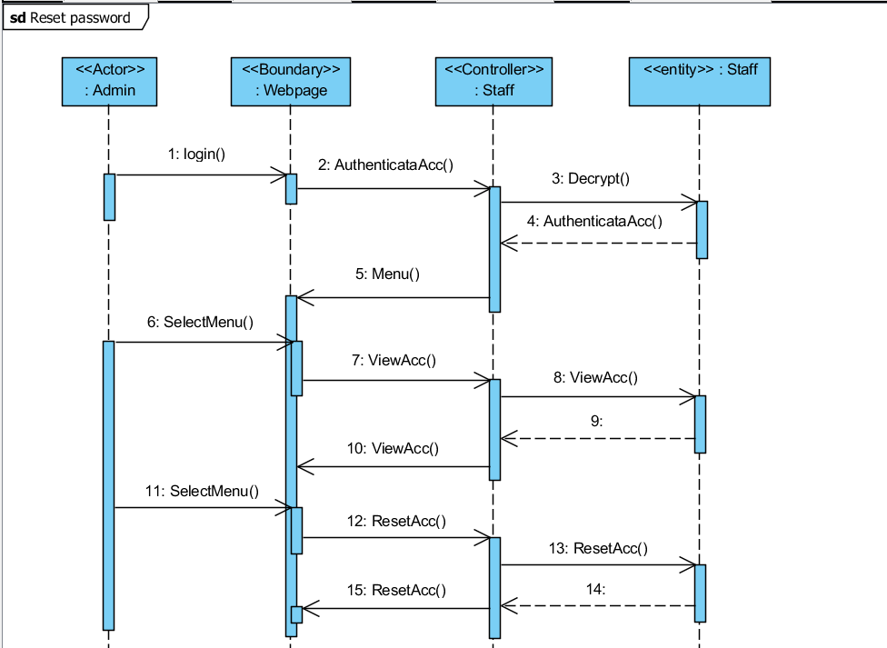
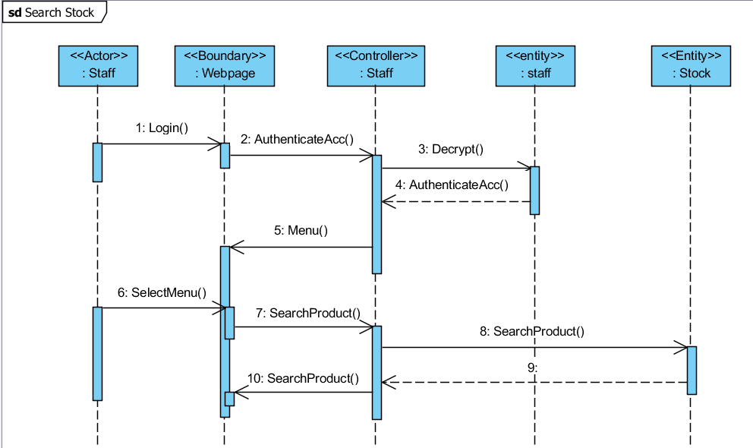

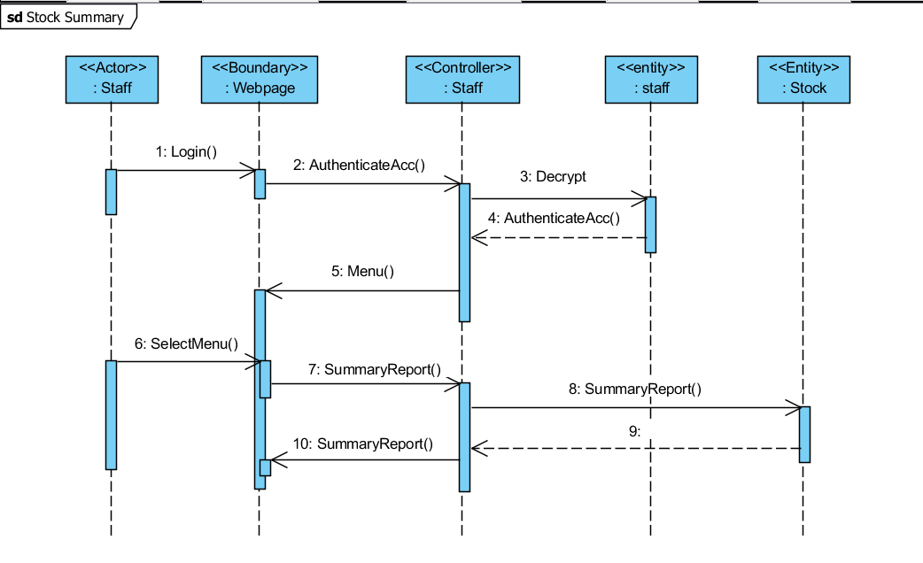
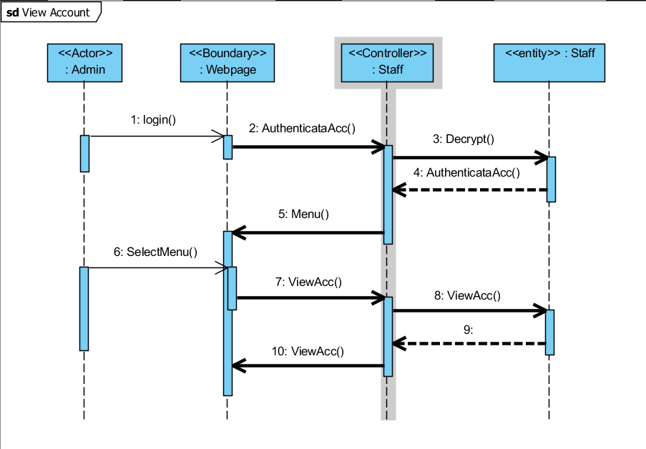

Design Artefacts - Deployment Diagrams (Iteration 1)

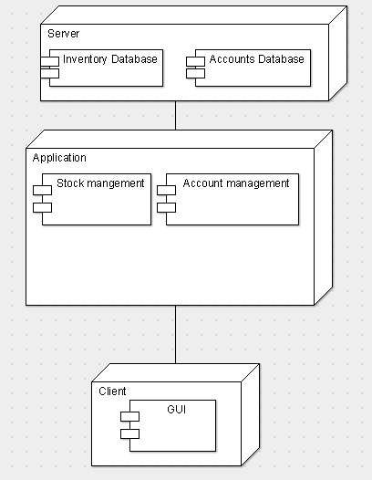

Design Artefacts - Deployment Diagrams (Iteration 2)

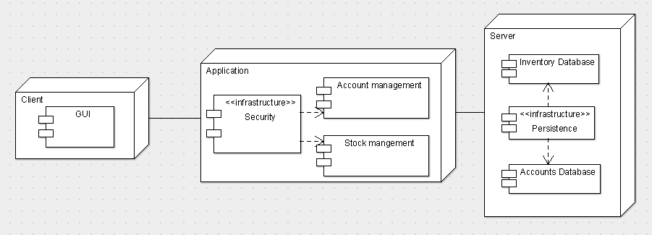

Design Artefacts - <Any other diagrams> (Iteration 1)

Depending on your system's software architecture, there may be many other diagrams (e.g. ER-Model, State / Interaction / Activity Diagrams, etc) which are applicable and should be reflected in your Design Artefacts section of your report.

Please "reuse the same structure" you see for the earlier sections on Use Case / Class / Component diagrams, together with 2 iterations version, for your diagrams in this section.

You may use any diagramming tool to develop your diagrams.

Iteration 1 is based on your team's "INITIAL" understanding of the system.

Note 1 : Your diagram should be developed using standard UML symbols and notations that is relevant for that particular type of diagram!

Note 2 : this section can span as many pages as necessary

Note 3 : If you are pasting screen-shots (from your adopted diagramming tool) into this sub- section, please ensure all the wordings / text are clearly visible

Design Artefacts - <Any other diagrams> (Iteration 2)

Depending on your system's software architecture, there may be many other diagrams (e.g. ER-Model, State / Interaction / Activity Diagrams, etc) which are applicable and should be reflected in your Design Artefacts section of your report.

Please "reuse the same structure" you see for the earlier sections on Use Case / Class / Component diagrams, together with 2 iterations version, for your diagrams in this section.

You may use any diagramming tool to develop your diagrams.

Iteration 2 is based on your team's "LATEST" understanding of the system.

In general, the diagrams in later iterations should be more refined, more evolved, capture more details than diagrams developed in earlier iterations

Note 1 : Your diagram should be developed using standard UML symbols and notations that is relevant for that particular type of diagram!

Note 2 : this section can span as many pages as necessary

Note 3 : If you are pasting screen-shots (from your adopted diagramming tool) into this sub- section, please ensure all the wordings / text are clearly visible

Test Plan Design

Depending on your system's software architecture, there may be many different classes, with many different implemented methods(), whose functionalities need to be tested.

Your team should describe how they intend to test their functionalities to ensure the methods() work as designed.

Below table provides a sample structure, to organize your content. You can reuse this structure to cover as many other important methods() as necessary.

Test Plan for :

<Relate to fuctional requirement>

Club Membership Management - The system should allow the administrator to add new members

Test Case ID: | Description | Expected Outcome | Participating Program's Class & Method to be tested | Participating CPPUnit Test Program's Class & Method doing the testing
E.g.  CM-1 | E.g.  To test for adding a new member's name "John Anderson" | E.g.  System should output a message like "Member : John Anderson created successfully".  The last array slot in the member array should contain the string " John Anderson " | E.g.  Class Name : ManageMember  Method Name :  bool createNewMember (string name) | E.g.  CPPUnit Class Name : TestManageMember  Method Name :  void testCreateNewMember (string name)
E.g.  CM-2 | E.g.  To test for adding an EXISTING DUPLICATE member's name "John Anderson" | E.g.  System should output a message like "Error, member : John Anderson already exists".  The total no. of elements in the member array should remain the same | E.g.  Class Name : ManageMember  Method Name :  bool createNewMember (string name) | E.g.  CPPUnit Class Name : TestManageMember  Method Name :  void testAddingExistingMember (string name)

Appendix A - Formal Meeting Records

Construction Phase - Iteration 1

- Copy and Paste your formal meeting minutes for Construction Phase, iteration 1 here.
- You can refer to Assn 1 Qn Paper, Appendix B, bullet point 4 for a summary of contents to be included.
- Note: this section can span as many pages as necessary

Construction Phase - Iteration 2

- Copy and Paste your formal meeting minutes for Construction Phase, iteration 2 here.
- You can refer to Assn 1 Qn Paper, Appendix B, bullet point 4 for a summary of contents to be included.
- Note: this section can span as many pages as necessary

Construction Phase - Iteration 3 (Optional)

- Copy and Paste your formal meeting minutes for Construction Phase, iteration 3 here.
- You can refer to Assn 1 Qn Paper, Appendix B, bullet point 4 for a summary of contents to be included.
- Note: this section can span as many pages as necessary

Transition Phase - Iteration 1

- Copy and Paste your formal meeting minutes for Transition Phase, iteration 1 here.
- You can refer to Assn 1 Qn Paper, Appendix B, bullet point 4 for a summary of contents to be included.
- Note: this section can span as many pages as necessary

Transition Phase - Iteration 2 (Optional)

- Copy and Paste your formal meeting minutes for Transition Phase, iteration 2 here.
- You can refer to Assn 1 Qn Paper, Appendix B, bullet point 4 for a summary of contents to be included.
- Note: this section can span as many pages as necessary

Appendix B - Individual Work Diaries

Team Member 1 : John Anderson

Construction Phase - Iteration 1

- Copy and Paste your formal meeting minutes for Construction Phase, iteration 1 here.
- You can refer to Assn 1 Qn Paper, Appendix B, bullet point 5 for a summary of contents to be included.
- Note: this section can span as many pages as necessary

Construction Phase - Iteration 2

- Copy and Paste your formal meeting minutes for Construction Phase, iteration 2 here.
- You can refer to Assn 1 Qn Paper, Appendix B, bullet point 5 for a summary of contents to be included.
- Note: this section can span as many pages as necessary

Construction Phase - Iteration 3 (Optional)

- Copy and Paste your formal meeting minutes for Construction Phase, iteration 3 here.
- You can refer to Assn 1 Qn Paper, Appendix B, bullet point 5 for a summary of contents to be included.
- Note: this section can span as many pages as necessary

Transition Phase - Iteration 1

- Copy and Paste your formal meeting minutes for Transition Phase, iteration 1 here.
- You can refer to Assn 1 Qn Paper, Appendix B, bullet point 5 for a summary of contents to be included.
- Note: this section can span as many pages as necessary

Transition Phase - Iteration 2 (Optional)

- Copy and Paste your formal meeting minutes for Transition Phase, iteration 2 here.
- You can refer to Assn 1 Qn Paper, Appendix B, bullet point 5 for a summary of contents to be included.
- Note: this section can span as many pages as necessary

Team Member 'N' : Xxxx Xxxx

Construction Phase - Iteration 1

- Copy and Paste your formal meeting minutes for Construction Phase, iteration 1 here.
- You can refer to Assn 1 Qn Paper, Appendix B, bullet point 5 for a summary of contents to be included.
- Note: this section can span as many pages as necessary

Construction Phase - Iteration 2

- Copy and Paste your formal meeting minutes for Construction Phase, iteration 2 here.
- You can refer to Assn 1 Qn Paper, Appendix B, bullet point 5 for a summary of contents to be included.
- Note: this section can span as many pages as necessary

Construction Phase - Iteration 3 (Optional)

- Copy and Paste your formal meeting minutes for Construction Phase, iteration 3 here.
- You can refer to Assn 1 Qn Paper, Appendix B, bullet point 5 for a summary of contents to be included.
- Note: this section can span as many pages as necessary

Transition Phase - Iteration 1

- Copy and Paste your formal meeting minutes for Transition Phase, iteration 1 here.
- You can refer to Assn 1 Qn Paper, Appendix B, bullet point 5 for a summary of contents to be included.
- Note: this section can span as many pages as necessary

Transition Phase - Iteration 2 (Optional)

- Copy and Paste your formal meeting minutes for Transition Phase, iteration 2 here.
- You can refer to Assn 1 Qn Paper, Appendix B, bullet point 5 for a summary of contents to be included.
- Note: this section can span as many pages as necessary

Appendix C - Evidence of using VCS (Version Control Software)

Version Control Software used: Github & Github Desktop

Screenshot #1 - Contents in the VCS's Root Folder containing all Repository Project Files

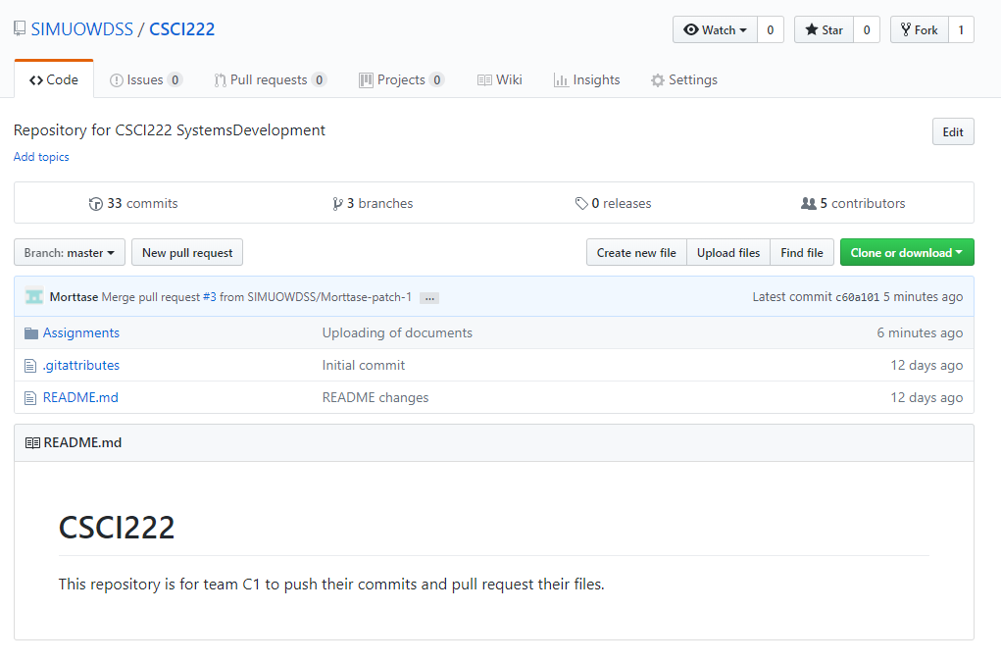
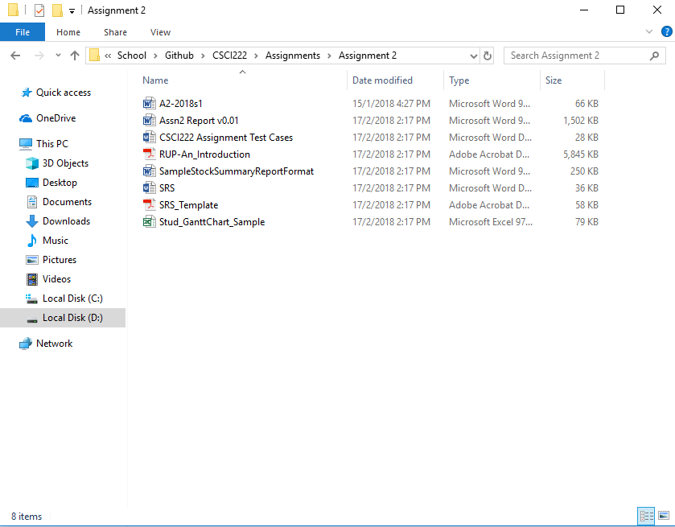
Figure C1.2 – The repository is cloned into your desktop based on the path you select. The folder then contains all the files and folders like in Github.

Screenshot #2 - VCS's listing of all the latest source files currently being managed

< Paste Screenshot #2 image here >

Screenshot #3 - Example using VCS's to check-out source files (it may be necessary to do >1 screen capture, depending on the software used)

< Paste Screenshot #3 image(s) here >

Screenshot #4 - Example using VCS's to check-in source files (it may be necessary to do >1 screen capture, depending on the software used)

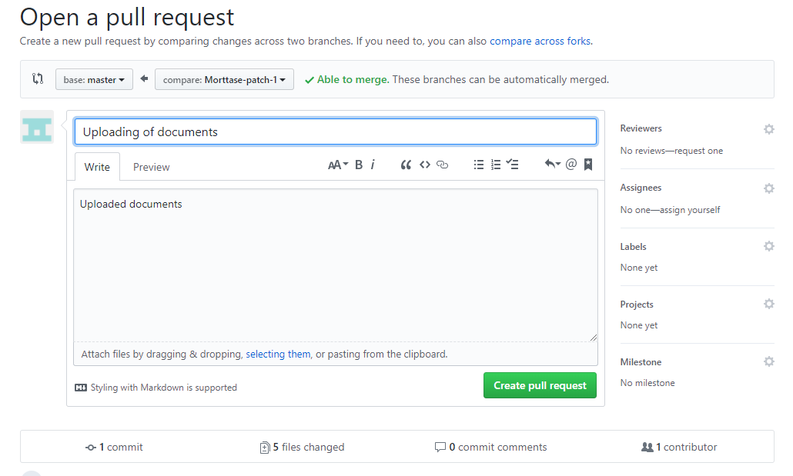
Figure C4.1 – This screenshot showcases the pull request that we are able to make upon uploading a file. Creating a pull request allows for the team to monitor the changed files before merging them into the master branch.
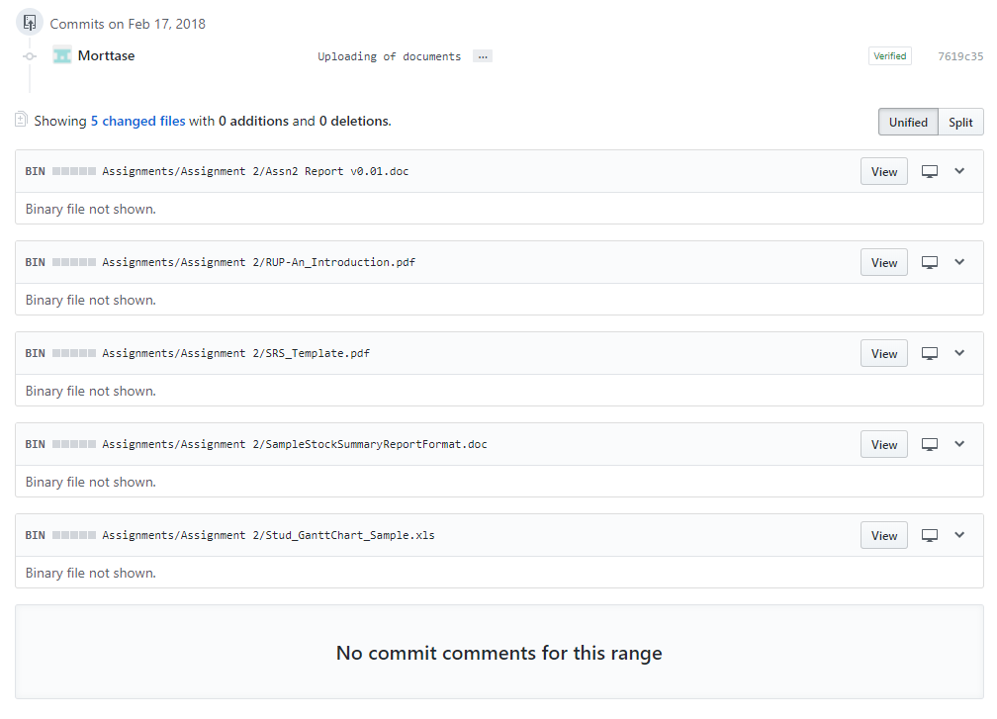
Figure C4.2 – This screenshot showcases all the changed files within a upload iteration by a particular user.
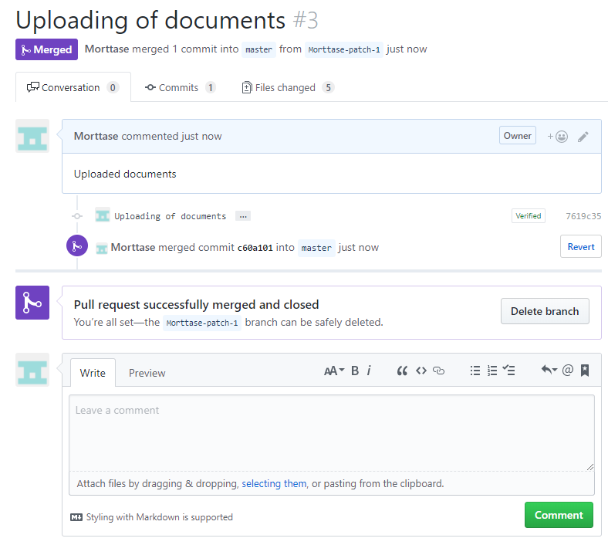
Figure C4.3 – This screenshot showcases the successful merging of documents. The repository will then be holding on to the latest version of the files that are edited and the pull request is then indexed.

Screenshot #5 - Example using VCS's to display the change history / log (it may be necessary to do >1 screen capture, depending on the software used)

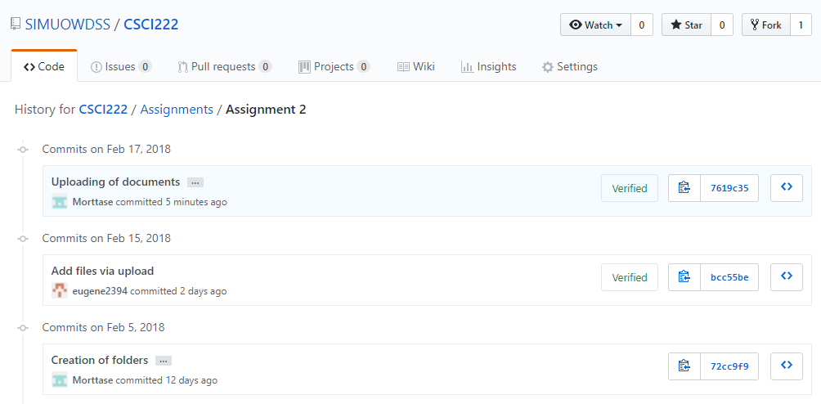
Figure C5.1 – This screenshot showcases the changes on the Github browser version.
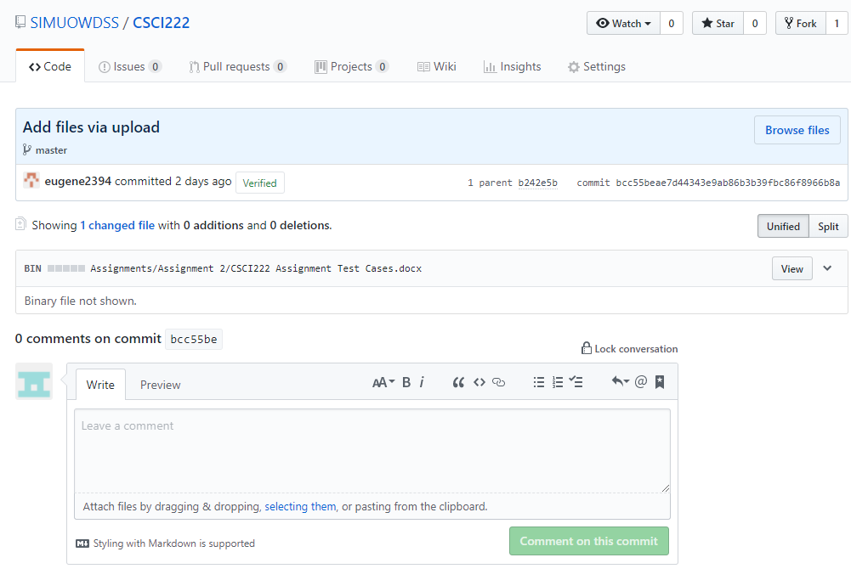
Figure C5.2 – This screenshot showcases a more detailed description of the changed file.
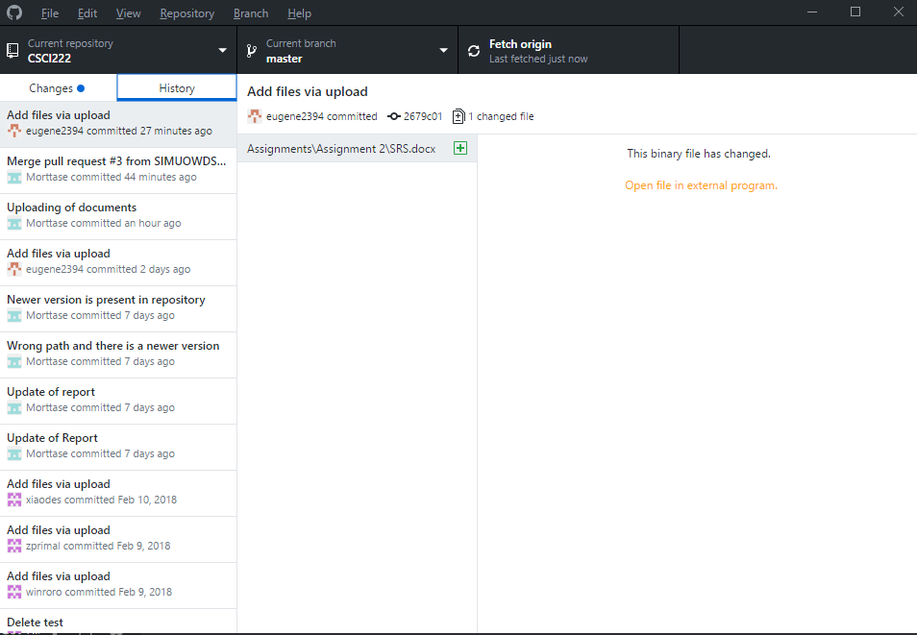
Figure C5.3 – This screenshot showcases the changes and history of changes made in Github Desktop GUI version.

